Experiment 1
Title
Install XAMPP / WAMP. Install Git and set up a new repository. Learn fundamental Git commands: add, commit, modify, view. Create and manage branches for version control.
Theory:

Local Server Environment (XAMPP / WAMP)
Web applications often require a server, database, and scripting language to function properly. Installing a live server for development and testing is neither economical nor practical for beginners. To overcome this limitation, local server environments such as XAMPP and WAMP are used.
XAMPP is a cross-platform software package that provides Apache web server, MySQL (or MariaDB) database, PHP, and Perl in a single installation. It allows developers to host and test dynamic web applications locally.
WAMP performs the same function but is limited to Windows operating systems.
These tools simulate a real hosting environment on a personal computer, enabling students to understand client-server architecture, server-side scripting, and database interaction without an internet connection.

Need for Version Control
During software development, source code is modified frequently. Managing multiple versions manually can lead to data loss, overwriting of files, and confusion. A Version Control System (VCS) solves these problems by maintaining a complete history of changes made to files over time.
Version control allows developers to:
- Track who made changes and when
- Restore previous versions of files
- Work collaboratively on the same project
- Maintain stable and experimental versions simultaneously
Types of Version Control Systems
There are two major types of version control systems:

Centralized Version Control System (CVCS)
In this system, a single central server stores the repository, and all users interact with it. Examples include SVN and CVS. If the central server fails, the entire system becomes unavailable.

Distributed Version Control System (DVCS)
In a distributed system, each user has a complete copy of the repository, including full
history. Git is a distributed version control system, making it faster, more reliable, and suitable for collaborative development.

Git as a Distributed Version Control System
Git is an open-source distributed version control system developed by Linus Torvalds. Unlike centralized systems, Git allows developers to work offline and commit changes locally. Synchronization with remote repositories can be done later.
Git efficiently tracks changes using snapshots instead of differences, which improves performance and reliability. Each commit represents a complete state of the project at a given time.

Git Repository Structure
A Git repository consists of:
- Working Directory – where files are edited
- Staging Area – where changes are prepared for commit
- Repository (.git directory) – where commits and metadata are stored
The repository maintains:
- Commit history
- Branch information
- Configuration settings
- Object database

Git Workflow
The standard Git workflow involves three stages:
- Modify – Changes are made in files
- Stage – Changes are added to the staging area
- Commit – Changes are saved permanently in the repository
This workflow ensures controlled and organized version tracking.
Fundamental Git Commands:
- git init
Initializes a new Git repository in a directory.
- git add
Adds modified or new files to the staging area.
- git commit
Saves staged changes as a snapshot with a descriptive message.
- git status
Displays the current state of the working directory and staging area.
- git log
Shows the history of commits along with commit IDs, author details, and timestamps.

Branching in Git
A branch represents an independent line of development. The default branch is usually named main. Branching allows developers to work on new features, bug fixes, or experiments without affecting the stable version of the project.
Git branches are lightweight and efficient, making branch creation and deletion fast operations.

Branch Management
Branch management includes:
- Creating branches for specific tasks
- Switching between branches
- Merging branches into the main branch
- Deleting obsolete branches
This mechanism enables parallel development and improves productivity in team projects.
Advantages of Git in Software Development
- Maintains complete project history
- Enables collaboration among multiple developers
- Prevents accidental data loss
- Supports branching and merging
- Allows rollback to earlier versions
- Works efficiently with remote repositories such as GitHub

Prerequisites
- Windows/Linux OS
- Internet connection
- Basic command-line knowledge
Procedure

A . Install XAMPP/WAMP
- . Download XAMPP from the official Apache Friends website.
- . Run the installer and select Apache, MySQL, and PHP components.
- . Complete installation and open XAMPP Control Panel.
- . Start Apache and MySQL services. 5. Verify installation by opening http://localhost in a browser.

B. Install and Configure Git
- . Download Git from the official Git website.
- . Install Git with default settings.
- . Open Git Bash and configure user details: git config --global user.name "Your Name" git config --global user.email youremail@example.com

Create Repository and Perform Git Operations
- . Open Visual Studio Code on the system.
- . Create a new folder named myproject.
- . Open the folder in VS Code
(File → Open Folder → select myproject).
- . Open the Terminal in VS Code (Terminal → New Terminal).
- Initialize a new Git repository in the project folder:
git init
- Create a new HTML file named index.html.
- Write basic HTML code in index.html and save the file:
<!DOCTYPE html>
<html>
<head>
<title>My First Git Project</title>
</head>
<body>
< h1>Hello Git</h1>
< /body>
< /html>
- . Check the status of the repository:
git status
- . Add the HTML file to the staging area: git add index.html
- . Commit the staged file with a commit message: git commit -m "Add index.html file"
- . Modify the HTML file by adding new content and save it:
<p>This file is tracked using Git.</p>
- . Check the status to view modified files: git status
- . Add the modified file to the staging area: git add index.html
- . Commit the updated HTML file: git commit -m "Update index.html content"
15. View the commit history:
git log
Branch Creation and Management:
- Create a new branch named feature git branch feature
- Switch to the new branch: git checkout feature
- Modify index.html by adding new content and save:
<p>This content is from feature branch.</p>
- Add and commit changes in the feature branch:
git add index.html git commit -m "Update index.html in feature branch"
  - . Switch back to the main branch:
git checkout main
  - . Merge the feature branch into main:
git merge feature
  - . View all branches:
git branch
Push Local Repository to Github.
    - Create a new repository on GitHub (without README).
    - Add GitHub repository as remote origin: git remote add origin https://github.com/username/repository-name.git
    - Push local main branch to GitHub:
git branch -M main git push -u origin main
Pull Changes From Github:
    - Make any change directly on GitHub (or from another system).
    - Pull latest changes into local repository:
git pull origin main
    - View Commit History
git log
Output: github profile and commands
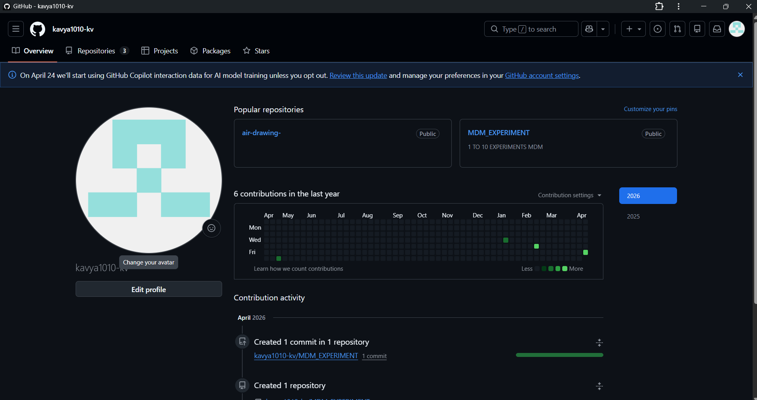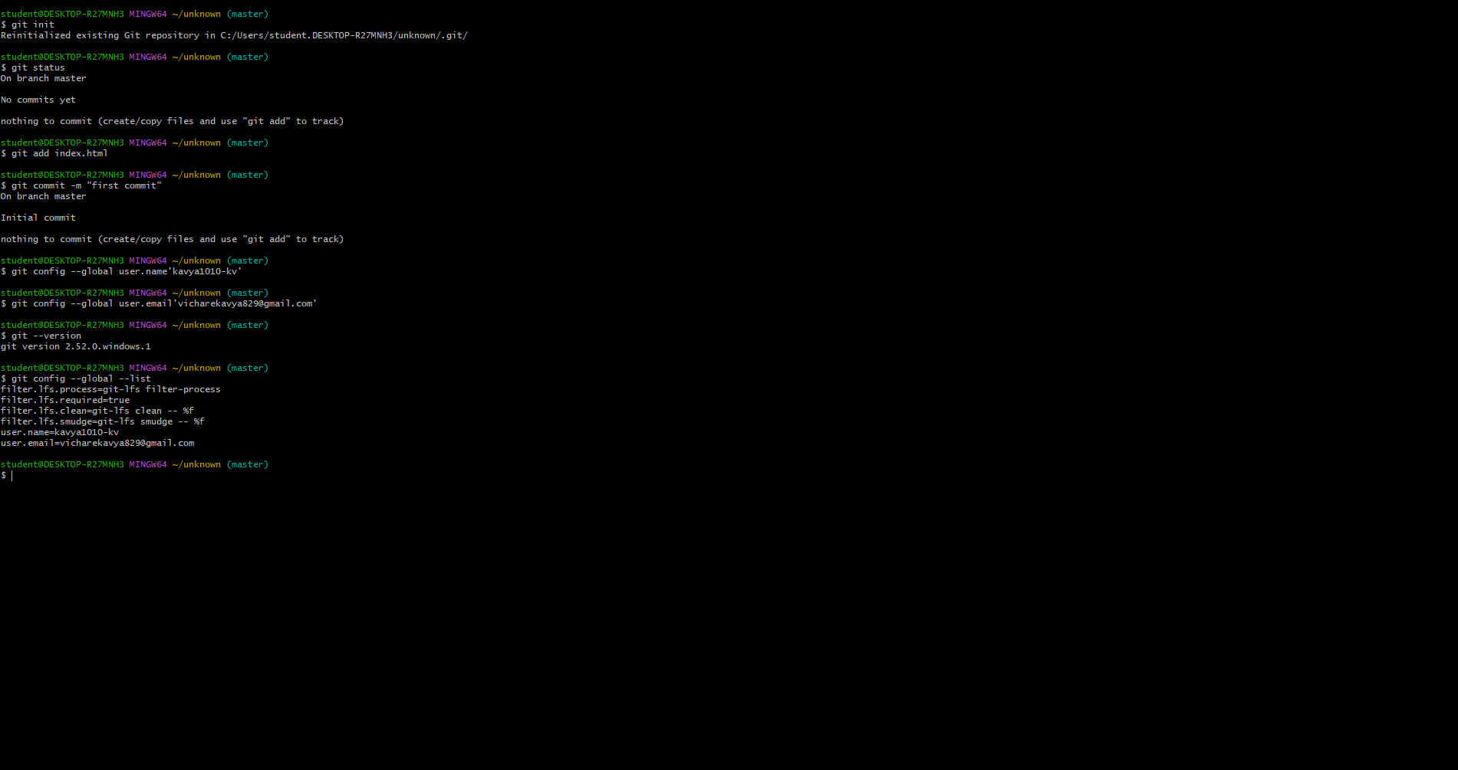

Conclusion
Thus, XAMPP/WAMP and Git were installed successfully. Basic Git commands were executed, and branch management was performed to understand version control operations.

